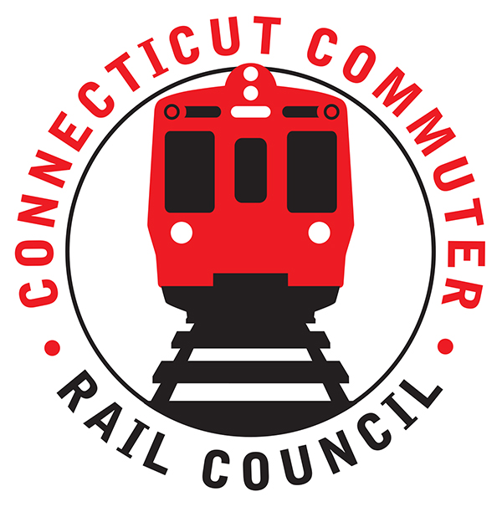

**AGENDA**

**Wednesday, August 28, 2019– 6:30 PM**

**Site: Valley Transit District**

**Meeting Room**

**Next door to the Derby Train Station**

**12 Main Street   
Derby, CT 06418**

|  |  |  |  |
| --- | --- | --- | --- |
| **1.** | **Welcome, introductions** | **Chair** | **6:30 p.m.** |
| **2.** | **Approval of July minutes** | **Council** | **6:32 p.m.** |
| **3.** | **Public Comments – 3 minutes each** | **Public** | **6:34 p.m.** |

**COUNCIL BUSINESS:**

|  |  |  |  |
| --- | --- | --- | --- |
| **1.** | **Commissioner Joseph Giulietti Branch Overview and Rail Discussion** | **CDOT** | **6:50 p.m.** |
| **2.** | **Passenger stranding incident 8/4 discussion** | **MNR / CDOT** | **7:10 p.m.** |
| **3.** | **Passing siding and Branch PTC – update and progress** | **MNR / CDOT** | **7:25 p.m.** |
| **4.** | **Let’s Go CT – Branch Locomotive and Coach upgrades** | **CDOT** | **7:40 p.m.** |
| **5.** | **Main line issues – questions for MNR** | **CDOT** | **7:55 p.m.** |
| **6.** | **Branch Line Issues – questions for MNR** | **CDOT** | **8:05 p.m.** |
| **7.** | **Adjourn** | **Council** | **8:15 p.m.** |

**NEXT MEETING:**

**Wednesday, September 18, 2019 – 6:00 PM**

**Grand Central Terminal**

**New York City**