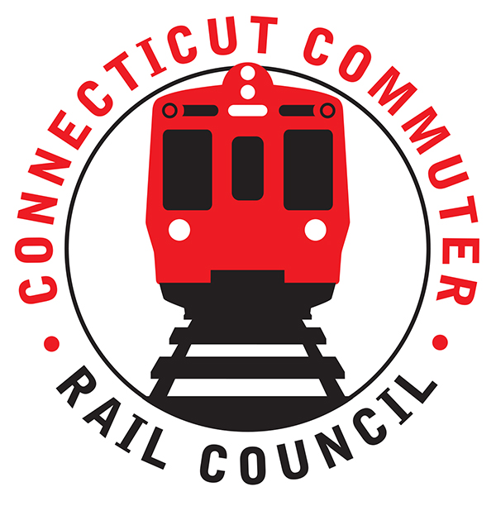

**Connecticut Commuter Rail Council**

**May 15, 2019**

**Conference Room**

**Norwalk Police Station**

**1 Monroe Street**

**Norwalk, CT 06854**

The following Council Members were in attendance: Jim Gildea, Jeffrey Maron, Lisa Slinsky, Peter Garneau, E.C. Schroeder and Roger Cirella. The following Council Members attended by phone: Sue Prosi, Laura Cordes, Terry Borjerson, Stephen Prostor, and Mitch Fuchs.

Introductions were made from the following people in attendance: Rich Jankovich, CDOT; Frank Pomes, MNRR, and members of the public.

The May Special Meeting Minutes were approved.

**Review and Discuss WALK Bridge Project**: The entire project is scheduled to be completed in 2024. The interlocking project is scheduled to be completed in July, 2021. The Danbury Dockyard project is scheduled to be completed in April, 2020. Terry Borjerson asked what the plan was for traffic. Sue Prosi mentioned there will be a brief period where the bridge is closed. Two actual outages are planned. The first outage will be in 2021. The outage is scheduled for a Thursday to Monday, late summer. One lift span will be replaced. The plan is a bus around.

The CP243 interlocking project is progressing. Site work has started.

Jeff Maron asked about the lawsuit by the Norwalk Harbor Keepers. Rich Jankovich did not know the status.

**Danbury Branch Let’s Go CT Update**: Metronorth is looking at the Branches. Locomotives are being overhauled. Rich Jankovich said a decision has been made on the locomotives but not on the coaches.

**Stamford Garage Repair (Review Question List)**:

1. Can they run Phase I (4 weeks of interior/stairwell work) and Phase 2 (roof level shear connector work) concurrently to minimize weather risk/exposure?

**Response**: Rich said they have not ruled that out yet.

1. What is the URL for the project, where they can post schedules/progress and people can register for updates?

**Response**: Rich said the URL will be put up.

1. a. When will all the spaces be repaired and functioning? **Response**: Rich said by Thanksgiving.

b. How many monthly permits are currently used? **Response**: 1372

c. How many people are on the waiting list for new permits? **Response**: 418

d. Are they planning on issuing more when the spaces are returned to use?

**Response**: Yes, they will start to issue monthly passes again.

e. Is there anything planned to address the vehicles that just park there for long periods of time?

**Response**: They need to rework the garage governance including issuing summonses for speeding/stop sign/parked outside of marked spots.

f. Is there a “market rate” pricing structure planned?

**Response**:

**Status of Proposed/New Stamford Garage, Including Support for Autonomous Vehicle Parking**:

No discussion.

**Update of M8’s running east of New Haven**: CDOT is continuing to work with Sistra, a consultant. CDOT is looking at the power demand. The project is taking longer than expected. Amtrak believes there may be a power shortage.

The M-8’s would be run by Amtrak. Jeff Maron asked about the possibility of one service provider. Rich Jankovich said the current contract calls for two providers.

Jim Gildea asked if there is enough equipment to run service. Frank Pomes said it would be a stretch now. There are plans for sixty-six (66) new cars this year. There will be 471 M8’s.

Sue Prosi asked what is the best timeline for service, worst case scenario?

Rich said the coaches are scheduled to be replaced in 2022.

Mitch asked how many coaches are designated for the shoreline? Rich said 24. Rich said there is a lot of work to do and there is a power study for service to New London.

**Main Line Issues-Questions for MNR**: No discussion.

**Branch Line Issues-questions for MNR**: No discussion.

Respectfully submitted,

Roger J. Cirella, Secretary