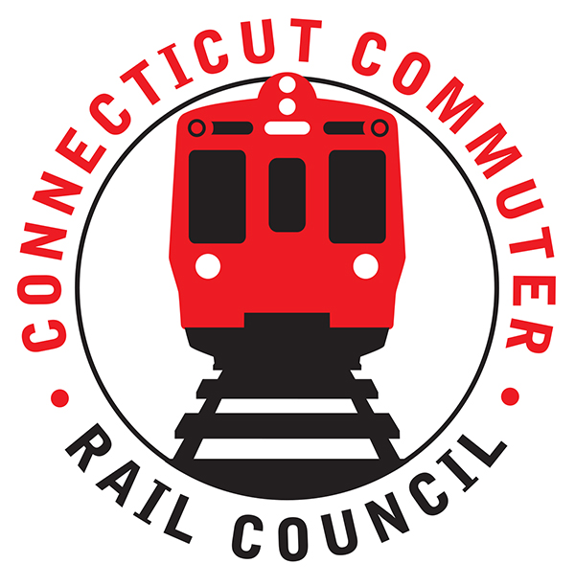

**AGENDA**

**Wednesday, July 17, 2019 – 7:00 PM**

**Donut Crazy**

**1 Ferry Lane, Westport CT**

**(Right at Westport Station)**

|  |  |  |  |
| --- | --- | --- | --- |
| **1.** | **Welcome, introductions** | **Chair** | **7:00 p.m.** |
| **2.** | **Approval of June minutes** | **Council** | **7:02 p.m.** |
| **3.** | **Public Comments – 3 minutes each** | **Public** | **7:04 p.m.** |

**COUNCIL BUSINESS:**

|  |  |  |  |
| --- | --- | --- | --- |
| **1.** | **Fourth Regional Plan Report** | **RPA** | **7:10 p.m.** |
| **2.** | **Positive Train Control Update** | **MNR** | **7:30 p.m.** |
| **3.** | **Atlantic Street Bridge Project Recap** | **MNR** | **7:45 p.m.** |
| **4.** | **Main line issues – questions for MNR** | **MNR** | **8:00 p.m.** |
| **5.** | **Branch Line Issues – questions for MNR** | **MNR** | **8:10 p.m.** |
| **6.** | **Ongoing work and investment needs at the STC** | **CDOT** | **8:20 p.m.** |
| **7.** | **Review Strategy Discussion and Next Steps** | **Council** | **8:30 p.m.** |
|  |  |  |  |
| **8.** | **Adjourn** | **Council** | **8:50 p.m.** |

**NEXT MEETING:**

**Wednesday, August 21, 2019 – 7:00 PM**

**Waterbury Branch**

**Valley Transit District Offices (next to train station)**