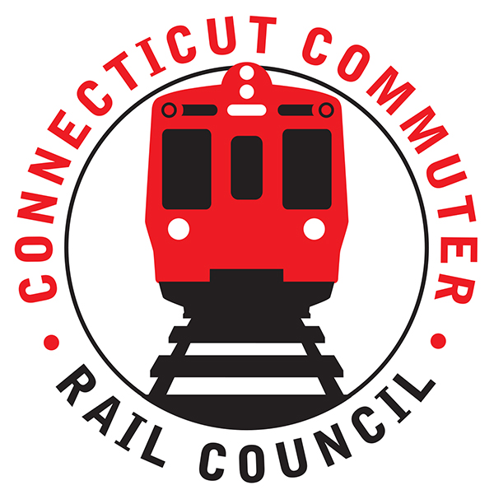

**AGENDA**

**Wednesday, June 19, 2019 – 7:00 PM**

**CDOT Conference Room**

**Stamford Transportation Center**

**30 Station Place**

**Stamford, CT 06902**

|  |  |  |  |
| --- | --- | --- | --- |
| **1.** | **Welcome, introductions** | **Chair** | **7:00 p.m.** |
| **2.** | **Approval of May minutes** | **Council** | **7:02 p.m.** |
| **3.** | **Public Comments – 3 minutes each** | **Public** | **7:04 p.m.** |

**COUNCIL BUSINESS:**

|  |  |  |  |
| --- | --- | --- | --- |
| **1.** | **Metro North Customer Service Satisfaction Results** | **MNR** | **7:20 p.m.** |
| **2.** | **Metrics on on-board fare collections/seat check policy adherence** | **MNR** | **7:45 p.m.** |
| **3.** | **Main Line Issues – questions for MNR** | **MNR** | **8:00 p.m.** |
| **4.** | **Branch Line Issues – questions for MNR** | **MNR** | **8:10 p.m.** |
|  |  |  |  |
| **5.** | **Stamford Station infrastructure (garage repairs, perpetual work on the access to track 5/kiss and ride by 95, escalator outages, etc.)** | **FUSCO/CDOT** | **8:15 p.m.** |
| **6.** | **Adjourn** | **Council** | **8:35 p.m.** |
|  |  |  |  |

**NEXT REGULAR COUNCIL MEETING:**

**Wednesday, July 17, 2019 – 7:00 PM**

**Site: Westport: TBD**