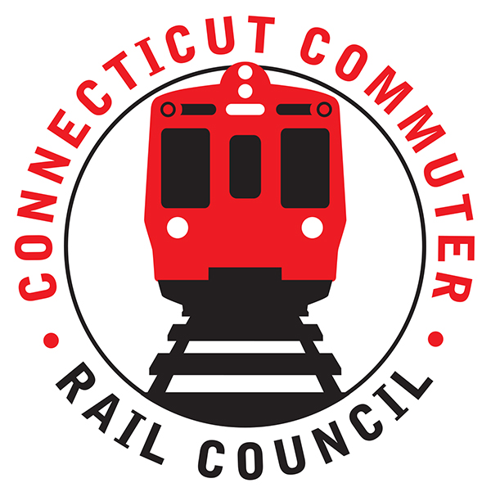

**Wednesday, February 20, 2019 – 6:00 PM**

**Conference Room**

**Greater Hartford Transit District**

**1 Union Place, Hartford, CT**

Jim Gildea opened the meeting at 6:05 p.m.

The following Council members were in attendance: Laura Cordes, Terry Borjeson, Stephen Prostor, Jim Gildea, Doug Hausladen and by phone: Sue Prosi, Lisa Slinsky, Mike Mahoney, Jeff Maron and Peter Garneau.

Introductions were made in the following people were in attendance: be Douglas Honn (TASI), Thomas Dunlap (Amtrak), Jim Carlson (Amtrak), Rich Jankovich (CDOT), Rich Andreski (CDOT), John Humphries (CT Roundtable on Climate & Jobs), Grace Y (City of Hartford), Kerri Provost, Anthony Cherolis (Transport Hartford and Center for Latino Progress), Sam Pudlin (Transport Hartford and Center for Latino Progress), Johnathan Dach (Office of the Governor), Orlando Velazco (City of Hartford), David McCluskey (West Hartford Resident), Don Soleyon (Amtrak), Kelly Costello (West Hartford Commuter), Adara Cohen (Amtrak), Brian McLaughin (CT Transit)

A motion was made by Douglas Hausladen to approve the minutes of the January 2019 Council meeting and seconded by Terry Borjeson. Motion carried unanimously.

From the public, Anthony Cherolis spoke to the Council. He presented a list of bills that were supported by Transit Hartford (attached). The Council mentioned their desire to be participative in the upcoming session and indicated they would stay in touch with Transit Hartford as bills moved through the legislative network.

Jonathon Dach, Governor Lamont‘s Deputy Chief of Staff spoke to the Council. He discussed the income needed to invest in transportation and spoke about different tolling options that would be explored during this year‘s legislative session. He also spoke about the new DOT Commissioner and the Governor’s desire to pursue a 30/30/30 vision.

Rich Jankovich gave a presentation on the Hartford line. Presentation attached.

Thomas Dunlap and Jim Carlson from Amtrak discuss the Hartford line and future capacity. They spoke about their belief that they had the ability to meet capacity by providing additional equipment when surge capacity is needed and known ahead of time. They also spoke about limiting advanced sales and the fact that this will also allow for more room on the HL.

The following questions were raised either by commuters via Twitter or Council members.

**Question:**

Will [@ShoreLineEast](https://twitter.com/shorelineeast) be getting the CTrail branding, ticket machines, etc that the Hartford Line got? It would be great to unify both lines that make up CTrail with consistent tech, equipment, and branding

**Answer:**

Per CDOT ...... yes, this is part of their plan. Mobile App first this year, then ticketing.

**Question:**

What's the holdup on getting M8s on SLE?

**Answer:**

Amtrak said they were on the last phase of testing. They have been able to get an M8 to run from New Haven to Stamford. It sounds like CDOT may not feel as if they have capacity to make it work. It did not sound promising

**Question:**

What's the status update on getting additional trains running north to Hartford in the morning? There are only 2 right now getting here before 9.

**Answer:**

CDOT said this is currently being looked at and fund availability will play a role. They are also looking into an earlier morning train from Stamford to get to Hartford earlier.

**Question:**

As for another gap in service, I went to the [@UConnWBB](https://twitter.com/UConnWBB) game last Monday. Game ended around 8:45 pm but people who were taking train back to New Haven has to wait until 10:28 Pm for a train. Why is there a 2 hour gap in service especially when there’s an UConn game at the [@XLCenter](https://twitter.com/XLCenter) ?

**Answer:**

CDOT said there are equipment issues but once all equipment is back from being worked on, it’s something they can do.

**Question:**

How is retrofitting the old Hartford line train cars for handicap restroom access going?

**Answer:**

They expect to have this issue resolved by the end of March

**Question:**

Could you ask about the planned service to Holyoke, Northampton and Greenfield, MA? It's supposed to be run by Amtrak and I'm wondering if the problem with capacity will affect this service as well. Supposed to be two trains a day in each direction beginning in July. Thanks.

**Answer:**

Amtrak reps said this service will happen this year.

**Question:**

Is there any plans to develop an app for CT Rail or will alerts and info continue to be posted through Twitter?

**Answer:**

Yes, in testing now

**Question:**

For reps of the Governor's office - can we expect a State Rail Plan for Connecticut?

**Question:**

CDOT will be responsible for this plan

A motion was made by Douglas Hausladen to adjourn the meeting at 8:12 p.m. and it was seconded by Terry Borjeson. Motion carried unanimously.